ASSIGNMENT NO-04

* **Problem Statement:-**

Create a private bucket in AWS and upload a file and check by presigned URL that you can access the file or not.

* **Steps:-**

1. Log in to AWS account and go to the S3 dashboard.Click on "Create bucket" to create a new S3 bucket.Choose a unique bucket name and select the region where user want to create the bucket.

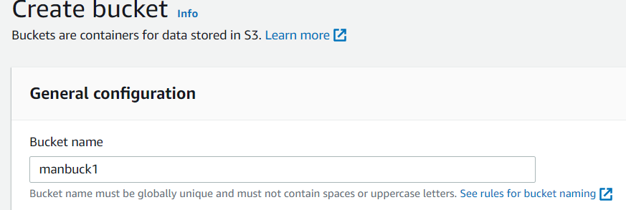

1. ACLs is disabled and left checked “Block all public access”and click create bucket.

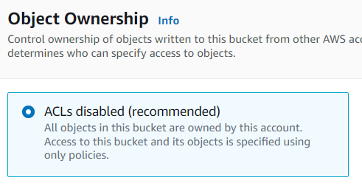

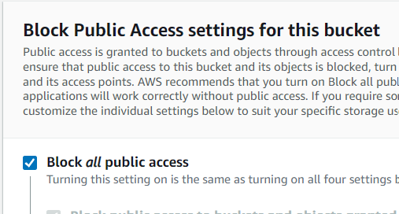

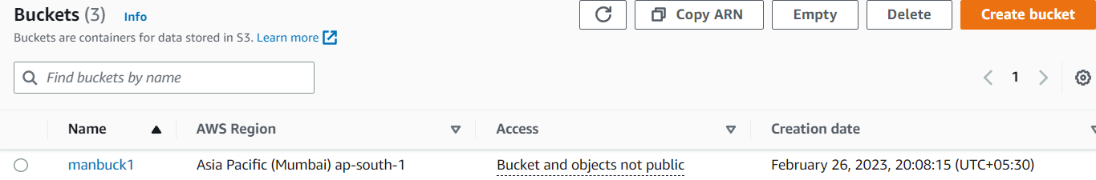

1. Click on the name(ex-manbuck1) and click on “Upload”.

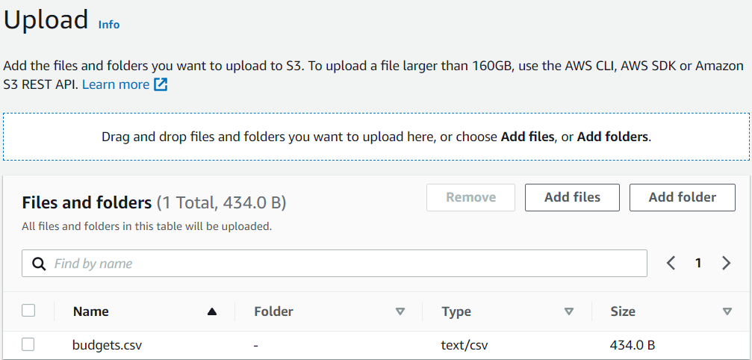

Now file is uploaded.

1. Now click on the file and click on object URLs and copy it and if it is pasted on a new tab then it can not be opened.

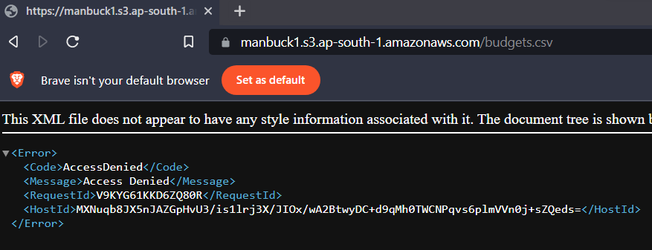

1. Now click on the file which is uploaded on the bucket (ex-budgets.csv)

And click on the “Object Actions” and click on the “Share with a presigned URL” and set timing as user’s choice and click on “create presigned URL”.

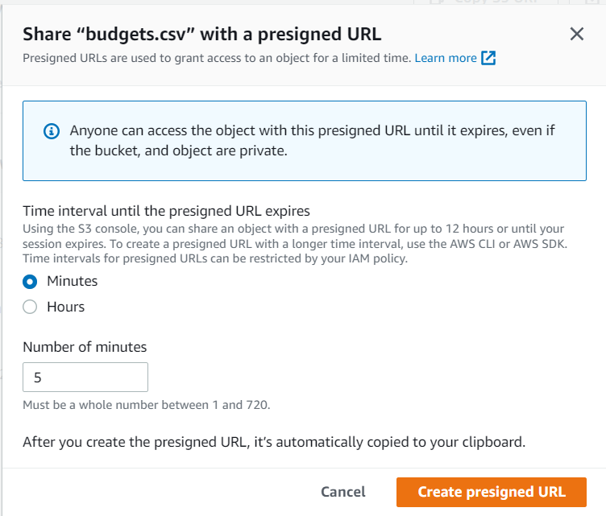

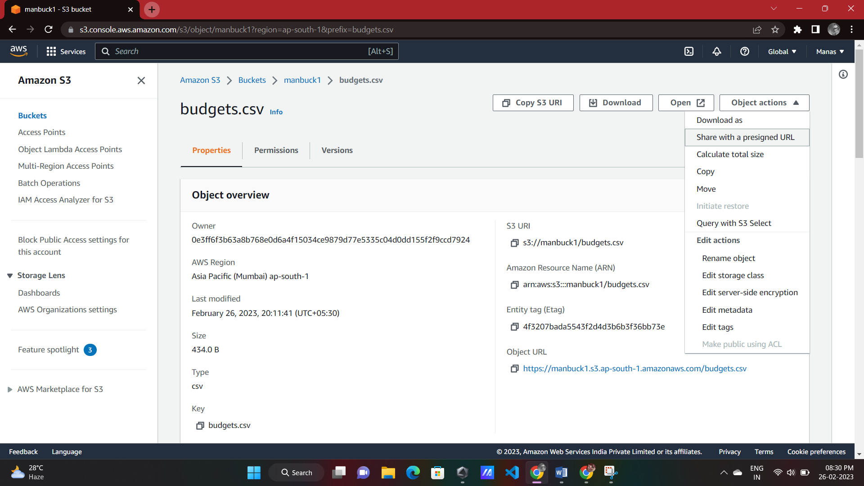

1. Now copy presigned URL and paste it into a tab and download the file and it will be active for 5mins.and the owner can share it.



ASSIGNMENT NO-05

* **Problem Statement:-**

Create a public bucket in AWS and upload a file and give the necessary permissions if the file URL is working or not.

* **Steps:-**

1. Log in to AWS account and go to the S3 dashboard. Click on "Create bucket" to create a new S3 bucket. Choose a unique bucket name and select the region where user want to create the bucket.

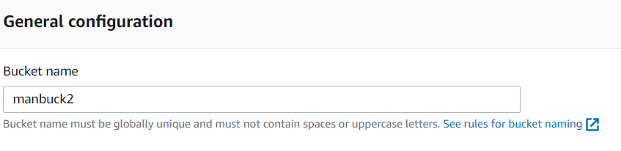

1. ACLs is enabled and unchecked “Block all public access”and click create bucket and click on the box “I acknowledge…” and create bucket.

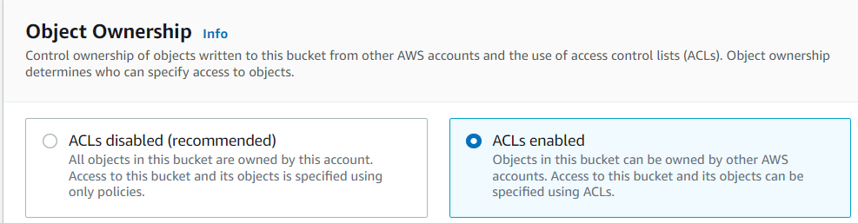

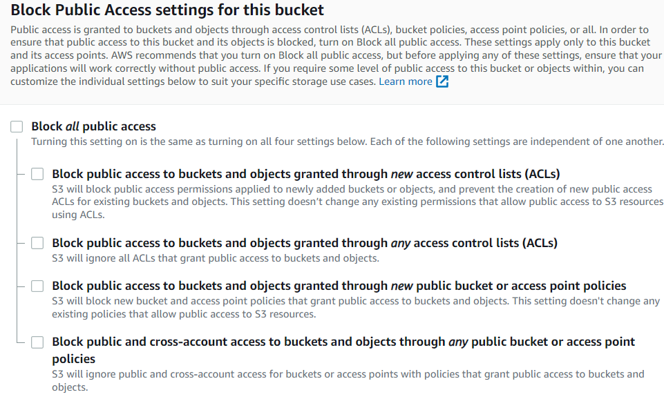

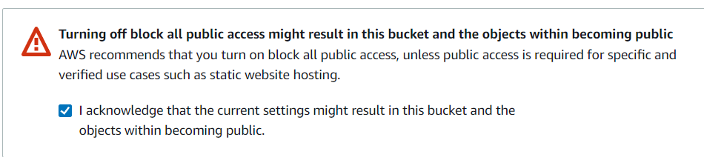

Now ,bucket is created.

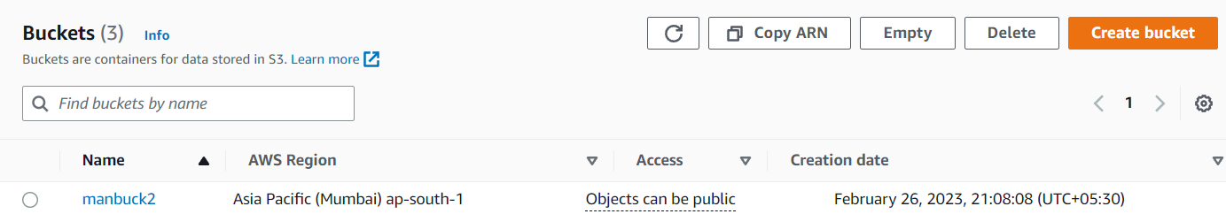

1. Now click on the bucket(ex-manbuck2) click on “Upload”.

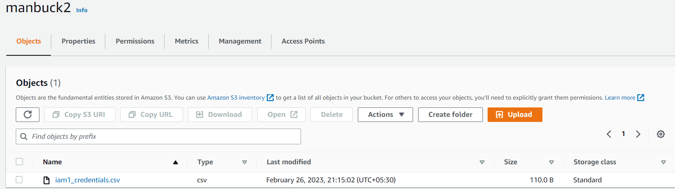

Now, file is uploaded.

1. Click on the file name and click on “object URL” and copy it and paste it on the new tab and we can see that the link is not opened .

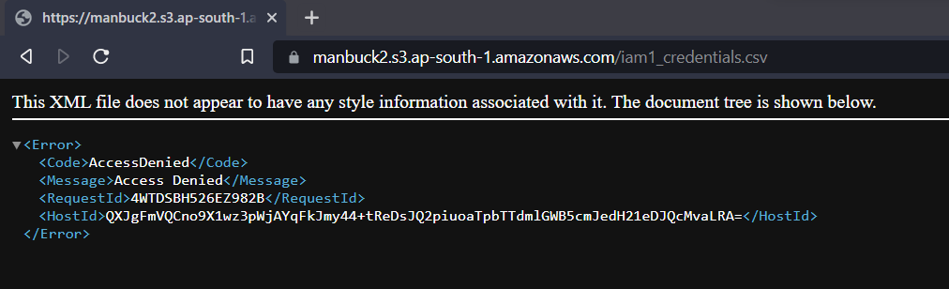

1. Now click on the file and go to permissions and click the edit button. And checked “Everyone (public access)” and check “I understand…”and click save changes.

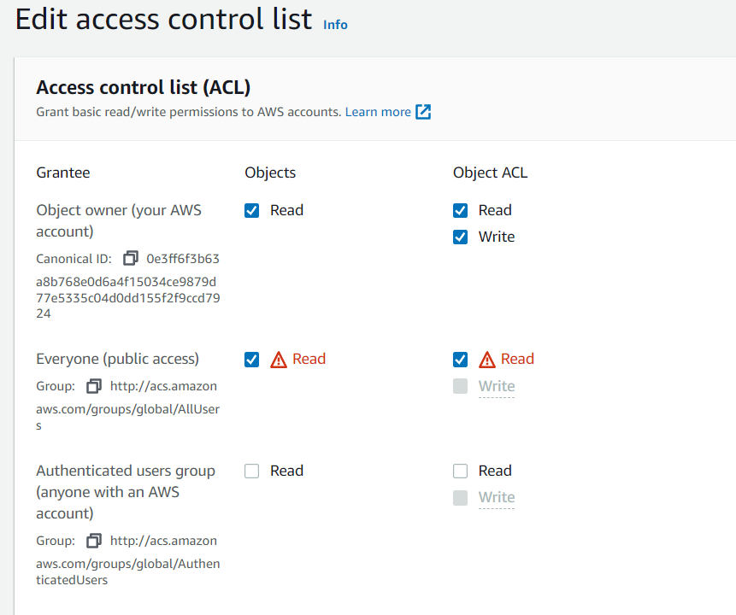

Now, if we click on the “object URL” the link can be opened and it is public now.

ASSIGNMENT NO-06

* **Problem Statement:-**

Upload a static website on S3 and run it.

* **Steps:-**

1. Log in to AWS account and go to the S3 dashboard. Click on "Create bucket" to create a new S3 bucket. Choose a unique bucket name and select the region where user want to create the bucket.ACLs is **enabled** and **unchecked** “Block all public access”and click create bucket and click on the box “I acknowledge…” and create bucket.

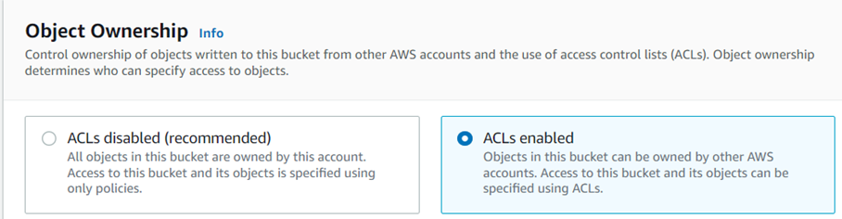

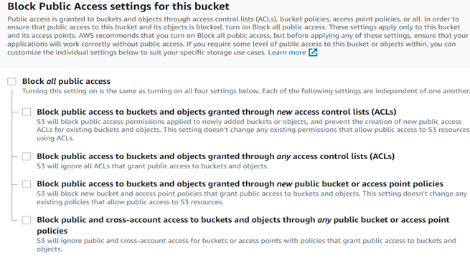

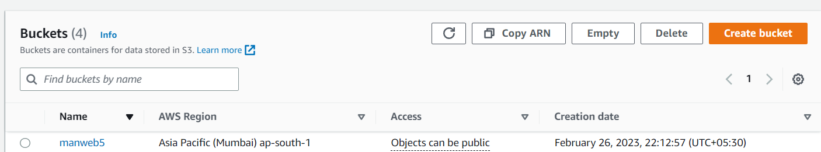

Now, bucket is created.

1. Click on the bucket and go to **properties .**at the bottom of the properties there is a option “Static website hosting” click on edit option.

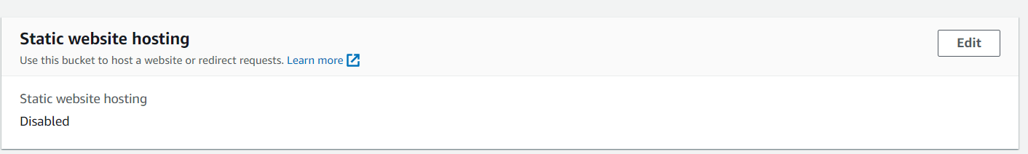

1. Click on enable . Enter the name in “Index document” index.html as it is index/main page of the website and left others as it is and click “Save changes”.

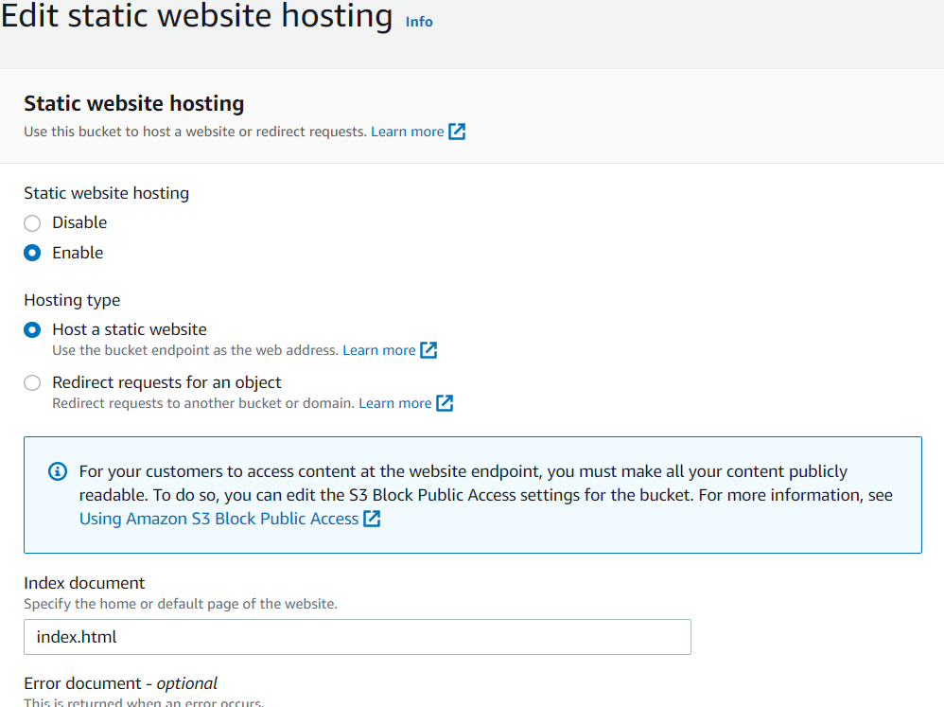

1. Now go to object again and click on “Upload” and upload more than one .html files or we can directly upload a folder which contains more than one .html files and click upload.

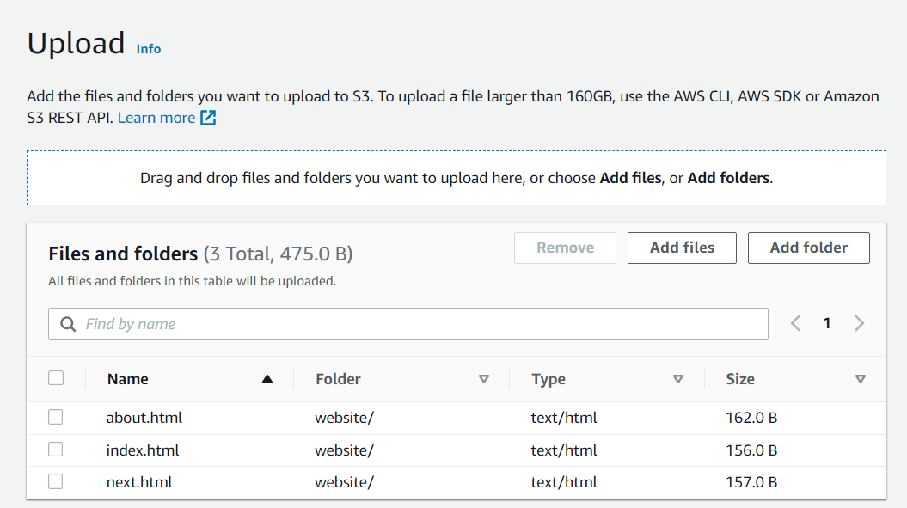

Now, files are uploaded.

1. Now come to bucket->object and click the check box in the left of folder(ex-website).

If we upload files separately then click every box.

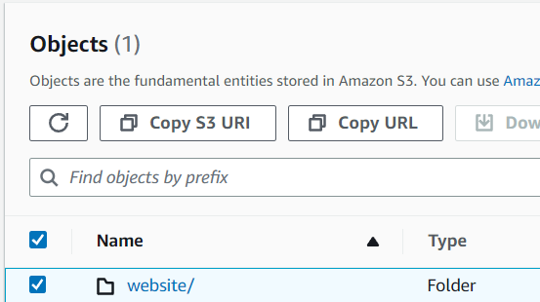

1. Click on “Actions” and click “Make public using ACL” then click make public.

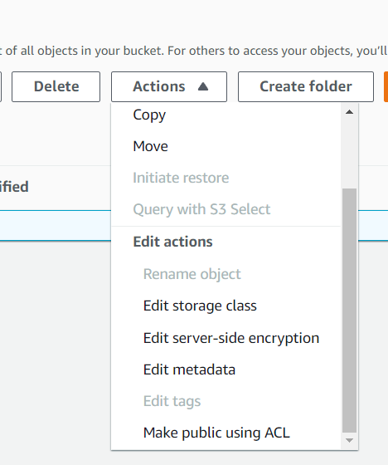

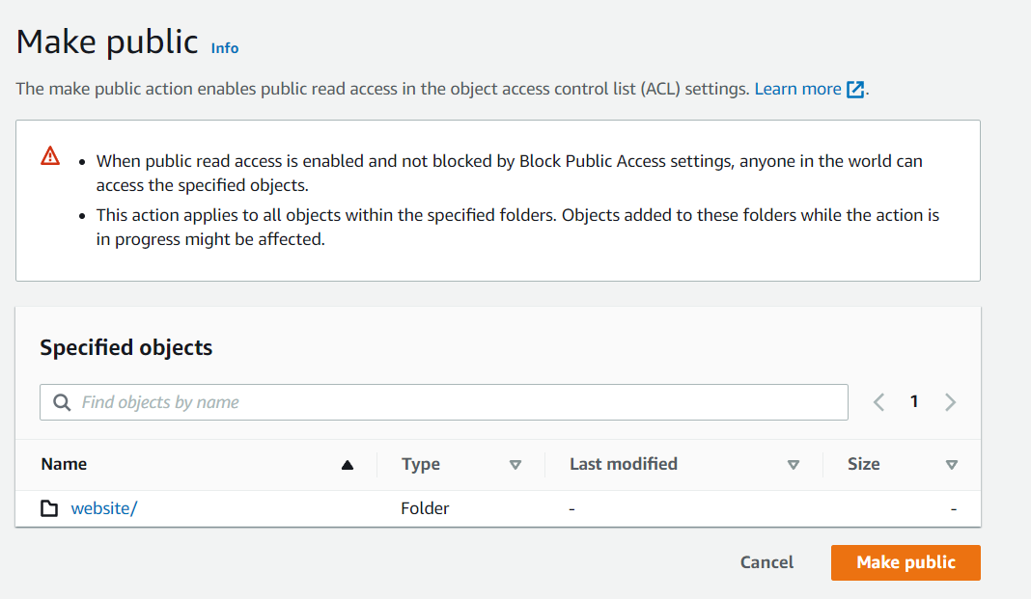

1. Now if we click on index.html and copy “Object URL”and paste it to another tab,these links are now public and can be opened .

